**Mohanlal Sukhadia University**

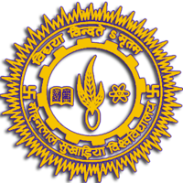

University College of Science

2020-21

Topic: Extension Activity

**Submitted by:**

**Submitted to:**

Dr. Avinash Panwar

Ali Asger Habib

BCA 5th Semester